**DATA ANALYTICS WITH TABLEAU**

ASSIGNMENT-2

1. DONUT CHART:-

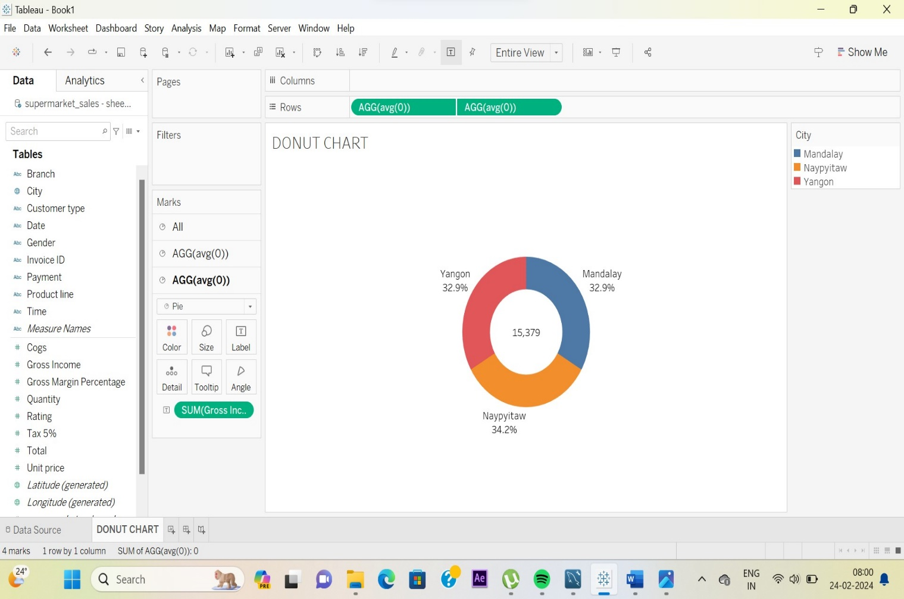

1. AREA CHART:-

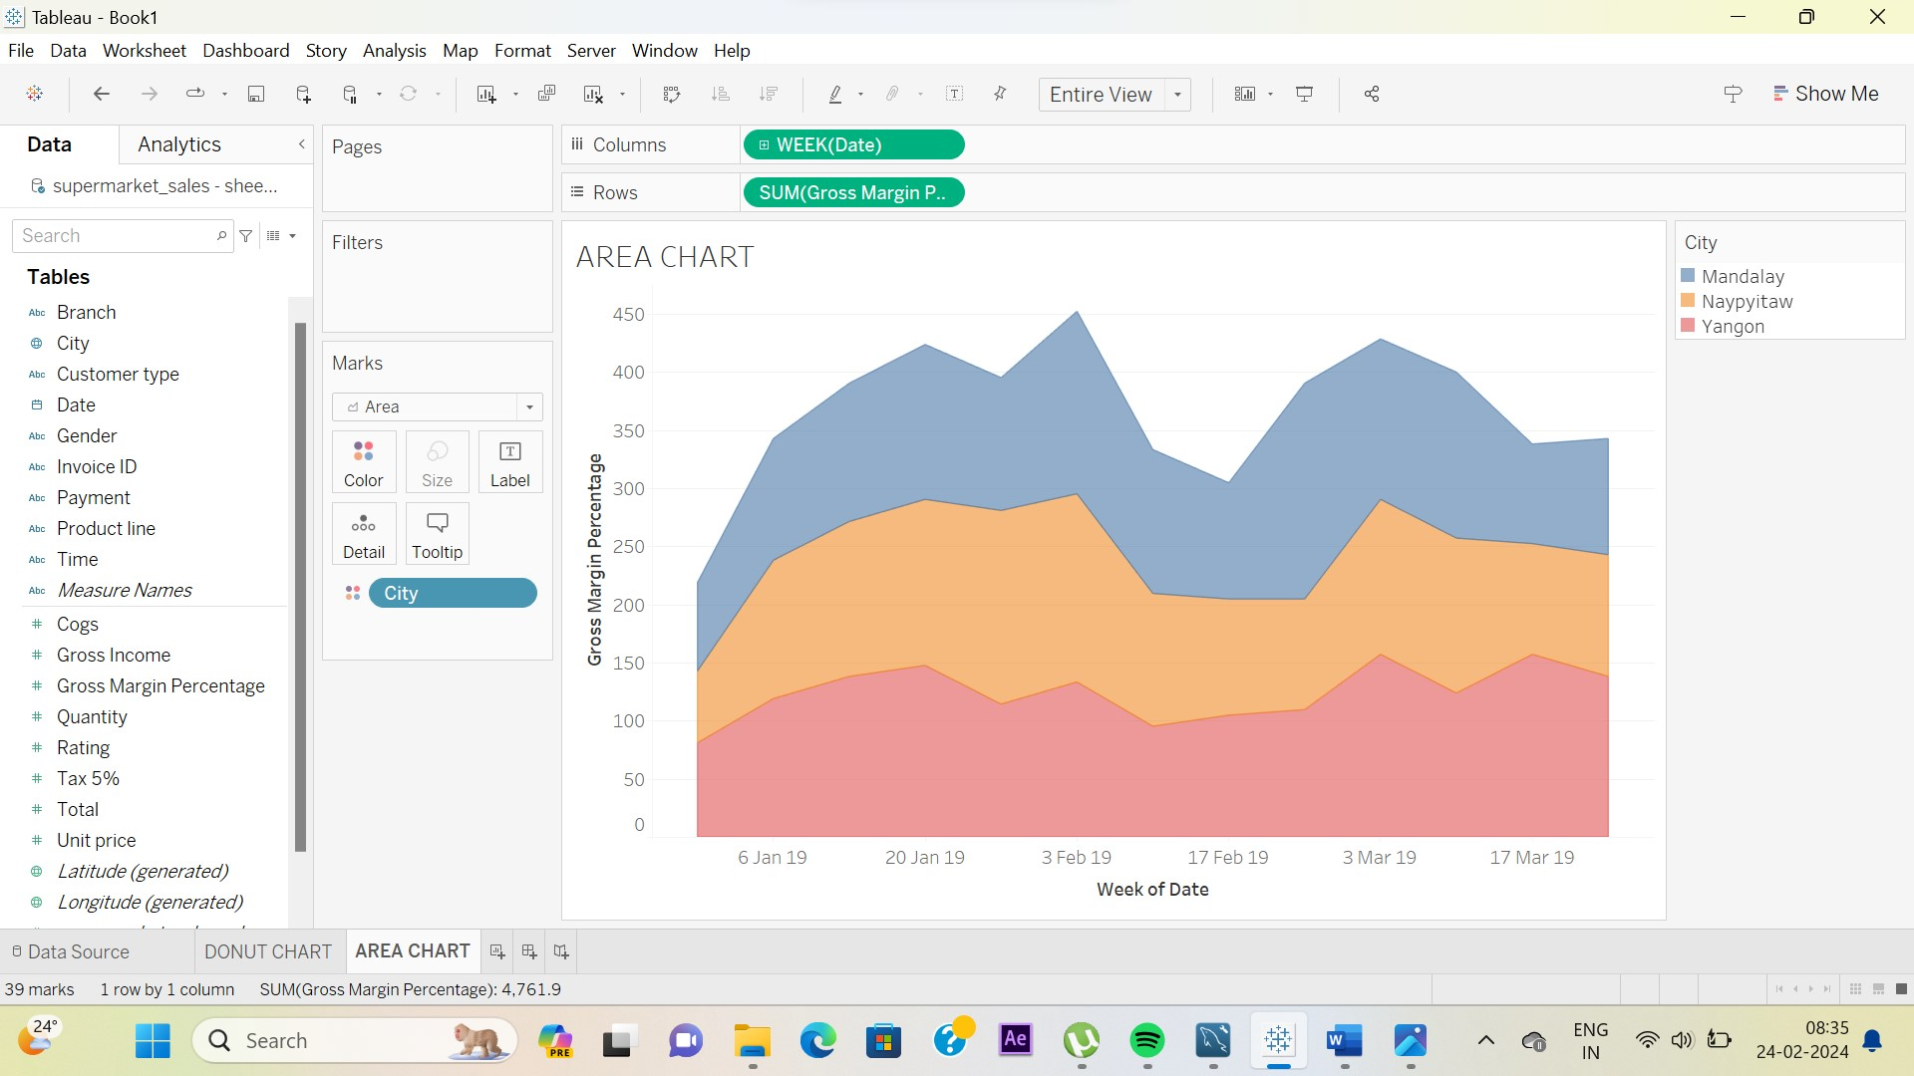

1. TEXT TABLE:-

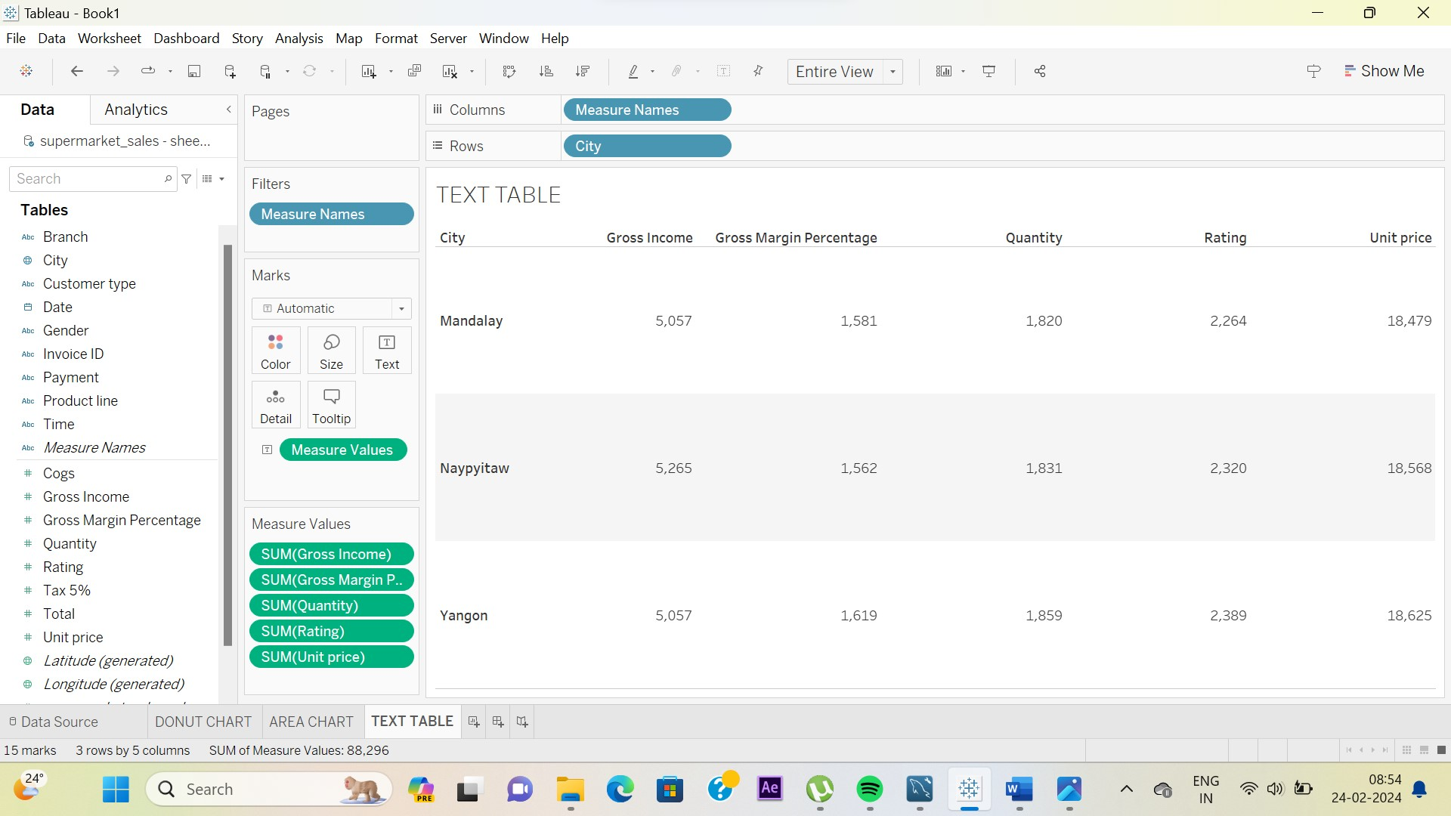

1. HIGHLIGHTED TABLE:-

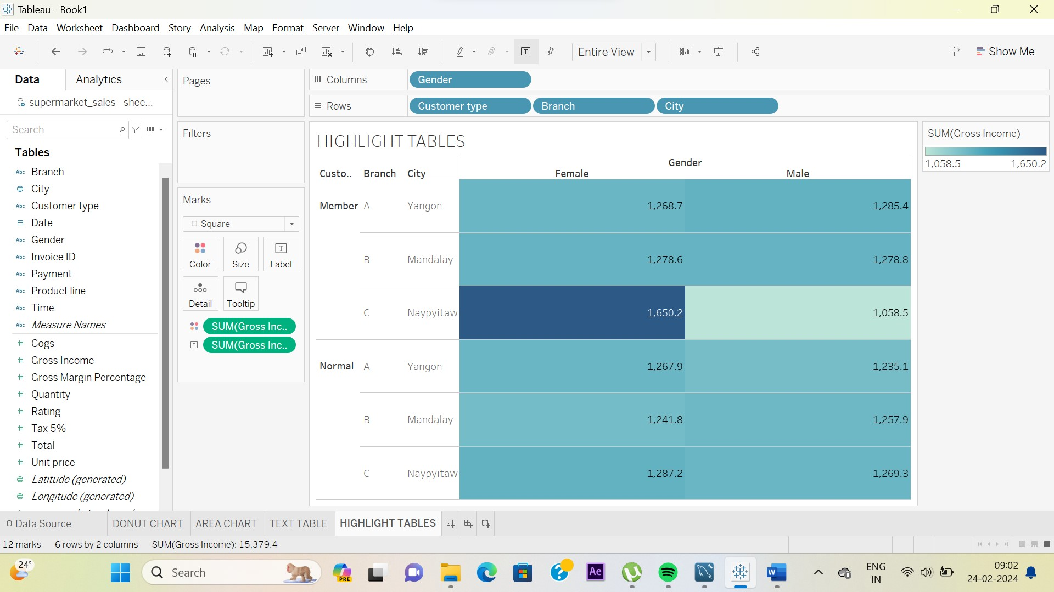

1. WORD CLOUD:-

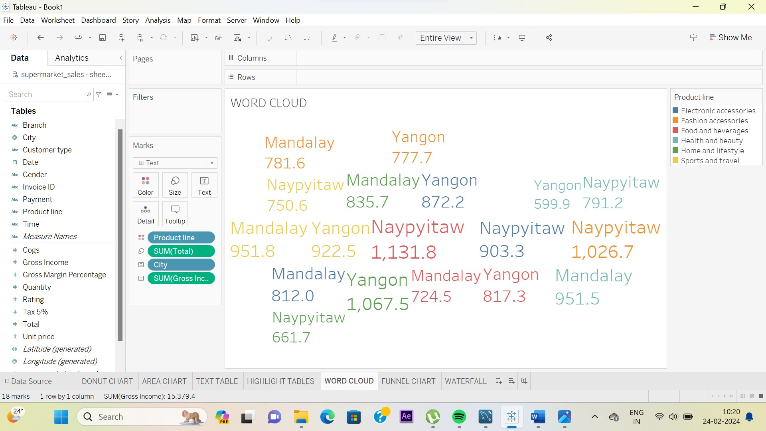

1. FUNNEL CHART:-

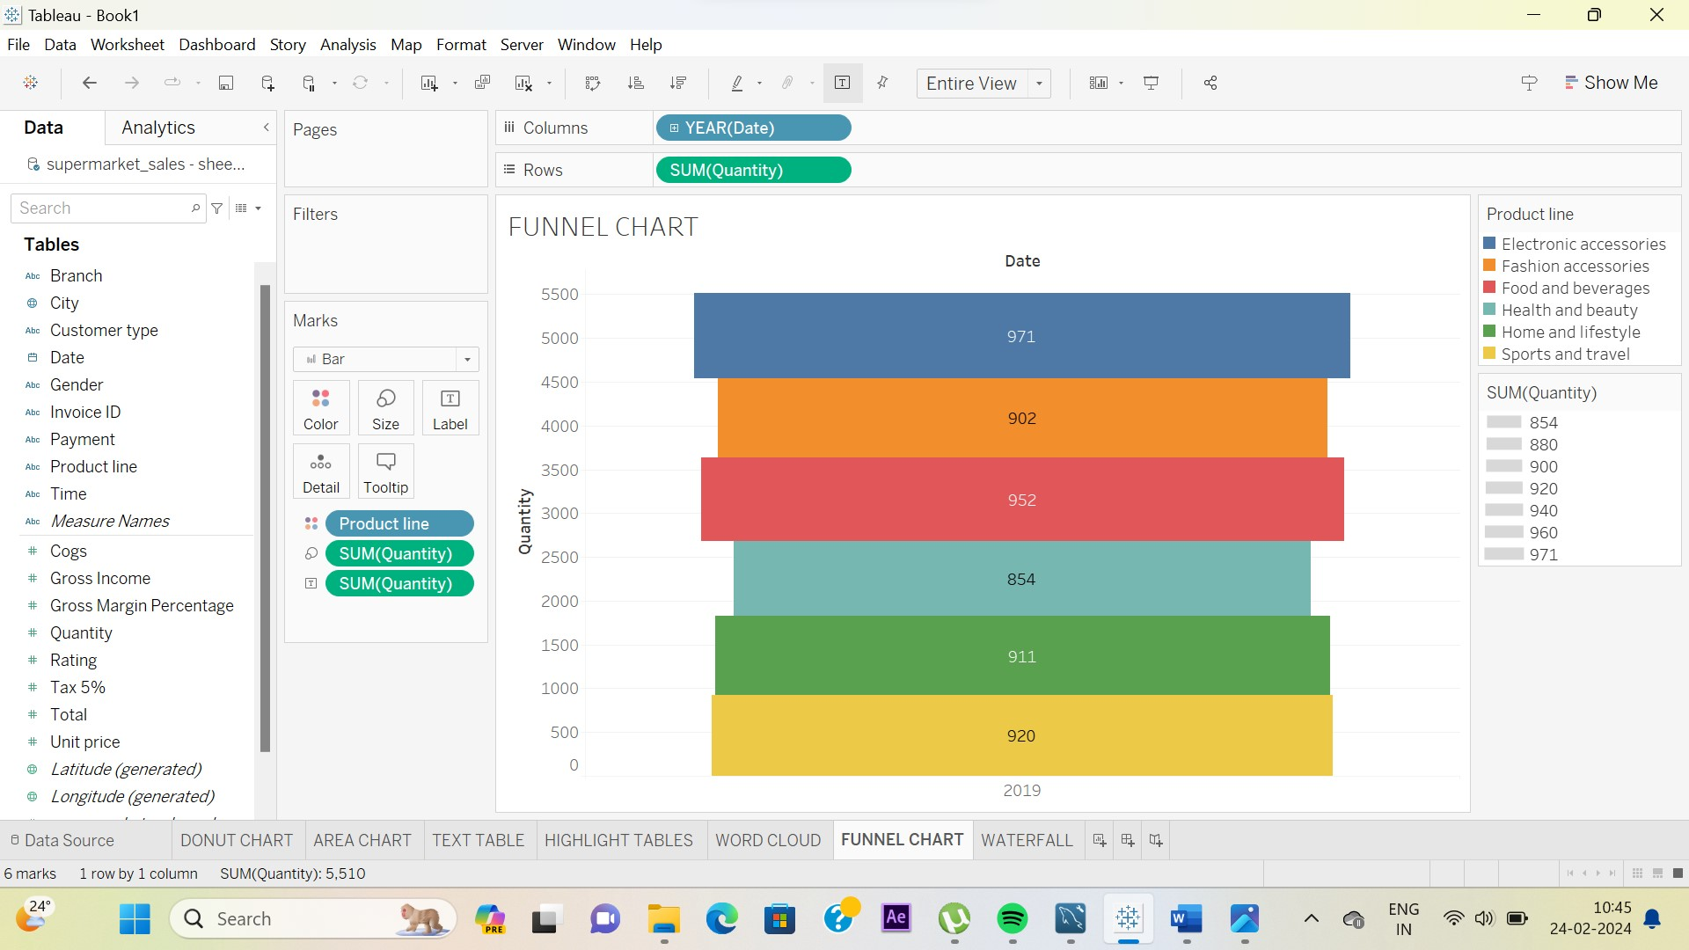

1. WATERFALL:-

